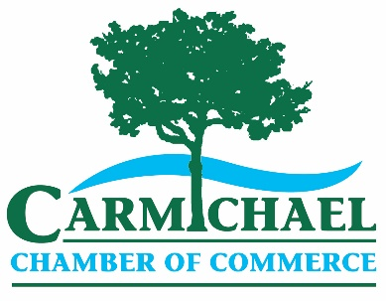**2019 Comprehensive Annual Sponsorship**

Annual sponsorship of the Chamber will help increase the exposure of your business and will display your support for the Chamber and the community. Sponsorship levels provide exposure throughout the entire calendar year, including recognition at our networking events.

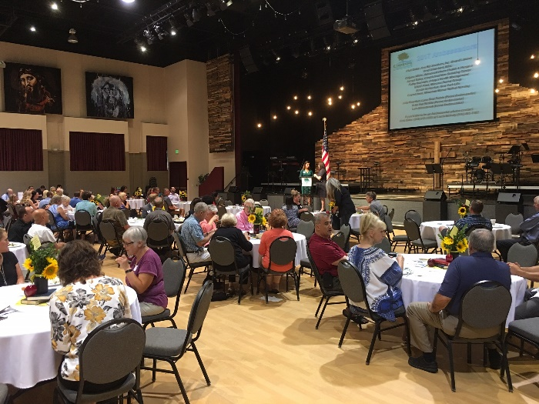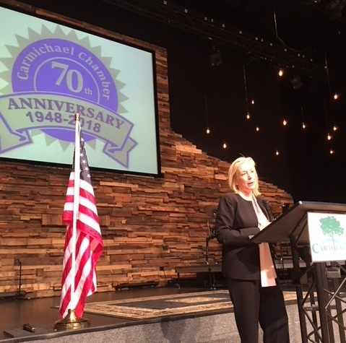

Monthly Luncheons

District Attorney Anne Marie Schubert addressing the Carmichael Chamber

|  |  |  |  |  |  |
| --- | --- | --- | --- | --- | --- |
| **Sponsorship Benefits** | **Diamond $5000** | **Platinum $3000** | **Gold**  **$2000** | **Silver**  **$1000** | **Bronze**  **$500** |
| Website sponsor w/ rotating banner | **🗸** |  |  |  |  |
| Ad in weekly Chamber e-blast | **🗸** | **🗸** | **🗸** |  |  |
| Free lunch(s) at monthly business luncheon )$20 per ticket) | **3** | **2** | **1** | **1** |  |
| Free year of Chamber membership ($150-$300) | **🗸** | **🗸** | **🗸** |  |  |
| One monthly luncheon sponsorship ($250 value) | **🗸** | **🗸** | **🗸** |  |  |
| Person of the Year event ticket(s) ($100 per ticket) | **4** | **4** | **2** |  |  |
| Complimentary seats at Best of Carmichael event | **4** | **4** | **2** |  |  |
| Booth/table display at one monthly luncheon | **🗸** | **🗸** | **🗸** | **🗸** |  |
| Table at annual Business-to-Business luncheon ($25 value) | **🗸** | **🗸** | **🗸** | **🗸** | **🗸** |
| Business Buzz e-blasts ($50 each) | **12** | **12** | **6** | **4** | **2** |
| Website recognition designating sponsorship level | **Logo** | **Logo** | **Logo** | **Name** | **Name** |
| Recognition in monthly luncheon PowerPoint | **Logo** | **Logo** | **Logo** | **Name** | **Name** |
| Recognition in weekly e-blasts (newsletter) | **Logo** | **Logo** | **Logo** | **Name** | **Name** |

For more information about sponsorship opportunities with the Carmichael Chamber, please contact Executive Director Virginia Stone at 916-481-1002 or 916 208-3328 or email

[execdir@carmichaelchamber.com](mailto:execdir@carmichaelchamber.com).